**Exp. No : 9**

**Implement clustering techniques – Hierarchical and K-Means**

1. **Hierarchical Clustering**

# Load the iris dataset

data(iris)

# Use only the numeric columns for clustering (exclude the Species column)

iris_data <- iris[, -5]

# Standardize the data

iris_scaled <- scale(iris_data)

# Compute the distance matrix

distance_matrix <- dist(iris_scaled, method = "euclidean")

# Perform hierarchical clustering using the "complete" linkage method

hc_complete <- hclust(distance_matrix, method = "complete")

# Plot the dendrogram

plot(hc_complete, main = "Hierarchical Clustering Dendrogram", xlab = "", sub = "", cex = 0.6)

# Cut the tree to form 3 clusters

clusters <- cutree(hc_complete, k = 3)

# Print the cluster memberships

print(clusters)

# Add the clusters to the original dataset

iris$Cluster <- as.factor(clusters)

# Display the first few rows of the updated dataset

head(iris)

**Output :**

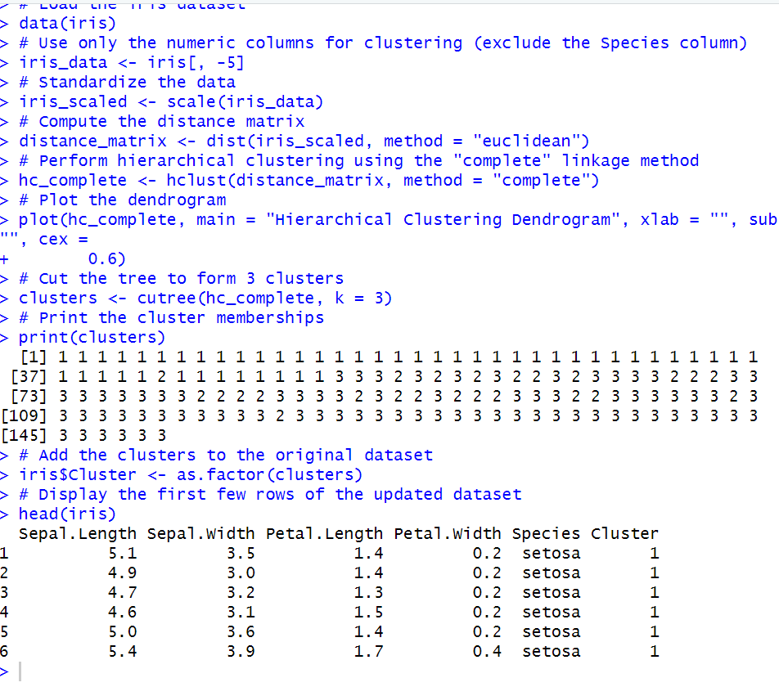

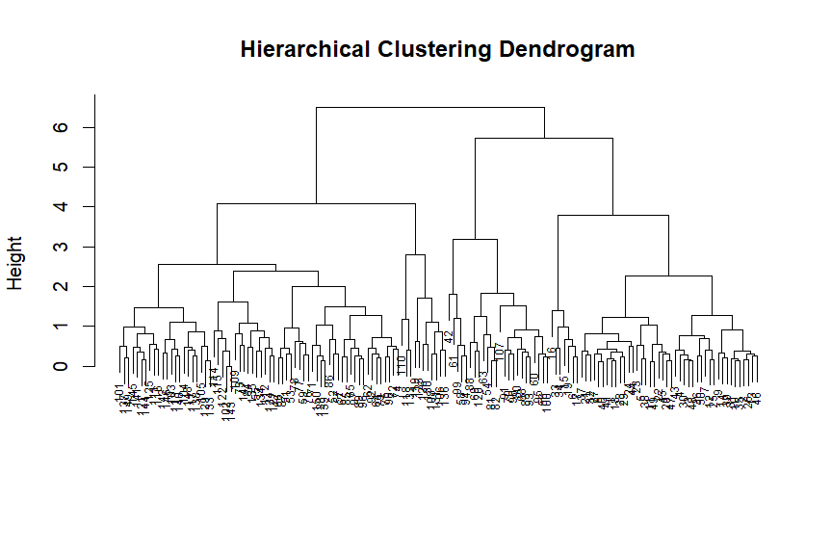

1. **K-Means Clustering**

# Load the iris dataset

data(iris)

# Use only the numeric columns for clustering (exclude the Species column)

iris_data <- iris[, -5]

# Standardize the data

iris_scaled <- scale(iris_data)

# Set the number of clusters

set.seed(123) # For reproducibility

k <- 3 # Number of clusters

# Perform K-Means clustering

kmeans_result <- kmeans(iris_scaled, centers = k, nstart = 25)

# Print the K-Means result

print(kmeans_result)

# Print the cluster centers

print(kmeans_result$centers)

# Add the cluster assignments to the original dataset

iris$Cluster <- as.factor(kmeans_result$cluster)

# Display the first few rows of the updated dataset

head(iris)

# Plot the clusters

library(ggplot2)

ggplot(iris, aes(x = Sepal.Length, y = Sepal.Width, color = Cluster)) +

geom_point(size = 3) +

labs(title = "K-Means Clustering of Iris Dataset", x = "Sepal Length", y = "Sepal Width")

**Output :**



